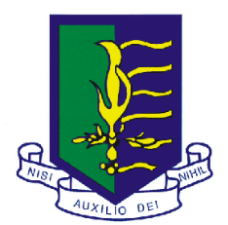
THE BARBADOS ST. MICHAEL ALUMNI (T0R0NTO) INC.
Under the distinguished patronage of Dr. Leroy McClean, Consul General for Barbados at Toronto

invites you to its

ANNUAL DINNER & DANCE

on
SATURDAY, OCTOBER 23, 2010
at
ALEX MANOOGIAN CULTURAL CENTRE
The Rembrandt Room

930 Progress Ave., Scarborough (South of 401, East of Markham Road)

Cocktails 6:00p.m. : Dinner 7:00p.m.

Guest Speaker: Michele Jordan, Vice President, Quality Improvement and Transformation

Rouge Valley Health System

Cash Bar
DJ: J. Caribbean Connections

Door Prize - A return trip for one to Barbados, compliments of

Marville Travel Limited and The Barbados St. Michael Alumni (Toronto) Inc.

Admission: $55.00

For tickets and more information please contact:
Joan 416-756-1070; Anita 905-814-7414; Gloria 905-819-9233;
Eunice 416-289-0903; Cecily 905-896-3270



